Annual Report (10/1/2024-9/30/2025)
Hands of Hope Resource Center, Inc.
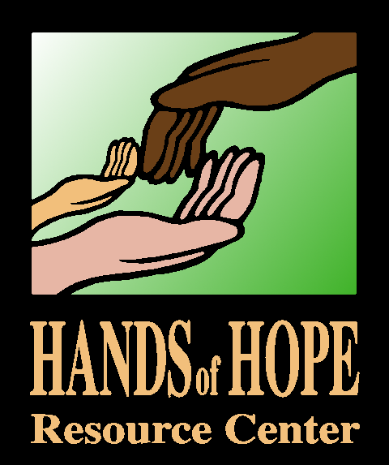

Making a difference…
“Counseling has been very helpful for my daughter! Having an alcoholic and abusive father has been very hard for her to deal with. The counseling has helped her to understand how to manage her anger, anxiety, and other feelings she's been struggling with and talk through her feelings. The counseling is helping her not to lash out, communicate better, and deal overall with the trauma instead of letting it negatively impact her. She doesn't have as many nightmares and is getting better grades. I'm thankful for the financial assistance from Hands of Hope to get my daughter counseling because it would be very challenging for me to afford it on my own as a single mother.”
~Anonymous Victim/Survivor

How can you help?
- Follow us on social media or signup for our newsletter.
- Volunteer.
- Join our governing board.
- Host an event to raise funds.
- Spread the word about our agency and our mission with your friends, family and co-workers.
- Donate money or supplies.
- Give to our annual Community Support Campaign.
- Purchase a DENIM DAY RAFFLE ticket!

PO Box 67, 107 2nd Street NE Little Falls, MN 56345
PO Box 171, 347 Central Ave Long Prairie, MN 56347
www.handsofhope.net 320-632-1657
We are pleased to share this report with you. Between October 1, 2024, and September 30, 2025, we served 332 domestic violence, 57 sexual assault, and 291 general crime adult and child victim/survivors and their loved ones in our two office locations.

We wish to thank all our volunteers, partners and donors for giving us the opportunity to serve those most vulnerable in our community. We could not offer 24-hour access to assistance without the 4,523 volunteer hours provided by our caring volunteer advocates.

Warmest regards,

Kristyna Chantry, Current Board Chair
Stephenie Och, Executive Director

OUR MISSION

Hands of Hope Resource Center advocates, educates and promotes societal change for those affected by violence and abuse. We provide free and confidential services in Todd and Morrison Counties. We serve those impacted by domestic violence, sexual assault, child abuse and other general crimes such as assault, burglary, stalking harassment and theft. We provide civil, criminal and medical advocacy for those seeking justice. We work closely with our partners in law enforcement, county attorney offices, social services and schools to support clients affected by crime and abuse. Our Violence Prevention Program provides prevention and other educational programming in the community and the schools on topics such as dating violence, healthy relationships, cyberbullying, sexting, and other topics as requested.
CURRENT BOARD OF DIRECTORS: Chair Kristyna Chantry, Assistant Morrison
County Attorney; Vice Chair Kim DeZurik, Morrison County Social Services;
Secretary Julie Sievert, H&R Block; Treasurer Eve Balfany, Morrison County
Community Corrections; Ed Moran, Morrison County Commissioner; Tim
Denny, Todd County Commissioner; Lisa Smude, CommonSpirit Health;
Melissa Larson, City of Staples Police Chief; and Brian Allen, Attorney at
Quinlivan and Hughes.

Financial Report

Highlights

MENTAL HEALTH ASSISTANCE
Through the assistance of focused grant funding, Hands of Hope Resource Center was able to support victims in receiving 67 counseling sessions by alleviating their out-of-pocket burden.

COMMUNITY PRESENTATIONS
Our agency provided 12 community presentations to 272 participants, and 54 total media contacts via print and radio spots.

CLIENT EVALUATIONS
There were 91 individuals completing evaluations with a 99% satisfaction rate. 100% felt that the advocate was supportive and listened without judgement; 98% felt that their advocate was knowledgeable about the issue they needed help with; 98% completed safety planning with an advocate; and 99% felt they were allowed to make their own decisions about what was best for their situation.

GRANT FUNDING
Primary grant funding for this fiscal year came from the Minnesota Department of Public Safety Office of Justice Programs Crime Victim Services grants, Medica Foundation, Mardag Foundation, Sourcewell, Morrison County Social Services, Minnesota Power Foundation, Initiative Foundation, Region V+ Adult Mental Health Initiative, Morrison County Area Foundation, and Morrison County United Way.

DONORS
Hands of Hope Resource Center is also supported by many businesses, community groups, and individual donors. With permission, we will begin listing these in FY2026.
Revenues | 2024-2025 | 2023-2024
Government grants | $432,768 | $370,572
Private & Special Project Grants | 88,193 | 190,304
Fundraising | 28,470 | 23,638
Contributions | 23,591 | 12,805
Offender fees | 595 | 2,198
Other Income | 6,434 | 3,868
Total | 580,051 | 603,385
Net Assets Released from Restrictions | 0 | 0
Total Revenues | $580, 051 | $603,385
Expenses
Domestic Violence | 176,214 | 166,461
Sexual Assault | 136,467 | 150,174
General Crime | 166,092 | 154,391
Emergency Assistance | 14,928 | 27,846
Violence Prevention | 3,216 | 2,401
Fundraising | 9,577 | 13,701
Management & General | 69,058 | 57,959
Total Expense | $575,552 | $572,933
Net Income | $4,499 | $30,452

Assets | 2024-2025 | 2023-2024
Cash (including Board designated reserve) & other deposits | $264,893 | $281,227
Grant & Other Receivables | 37,549 | 39,394
Prepaid expenses | 9,923 | 10,581
Furniture & Equipment (net) | 21,925 | 9,215
Total Assets | $334,380 | $340,417
Liabilities
Accounts Payable | 1,296 | 1,396
Accrued Expenses | 24,865 | 25,674
Deferred Revenue | 14,340 | 23,967
Total Liabilities | $40,501 | $51,037
Net Assets
Without Donor Restrictions:
Designated Operating Reserve | 143,013 | 143,013
Unrestricted | 136,061 | 137,853
Total Without Donor Restrictions | 279,074 | 280,866
With Donor Restrictions | 14,805 | 8,514
Total Net Assets | $293,879 | $289,380
Total Liabilities & Net Assets | $334,380 | $340,417
Our complete 990 may be viewed by going to our website.

